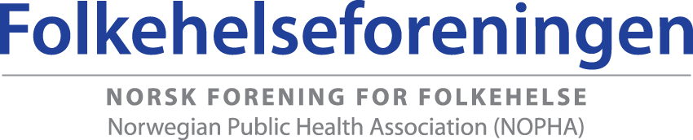

STRATEGIC PLAN 2013 – 2017
- INTRODUCTION
The Norwegian Public Health Association (NOPHA) was established in 1998. The Association works across disciplines for an increased understanding of and interest in research, teaching, dissemination, policymaking, management and practice within the field of public health.
The field of public health is here understood as “society’s total efforts in maintaining, improving and promoting public health. In this lies the need to strengthen the values which give each individual and group the opportunity for responsibility, participation, solidarity, mastering and control over their own lives and situations” (Public Health Act, NOU 1998: 18 Det er bruk for alle, White Paper no. 16 (2002-2003): Resept for et sunnere Norge and White Paper on public health 2013).
The Norwegian Public Health Association (NOPHA) is a member of the European Public Health Association (EUPHA) and the World Federation of Public Health Associations (WFPHA).
The Association is open to people, organisations, companies and institutions that are interested in research and development within health promotion, prevention, treatment and rehabilitation (NOPHA’s statutes § 3).
- TODAY’S SITUATION/DESCRIPTION OF THE PROBLEM
In a society which is characterised by, amongst other things, individualisation and medicalisation, there is a real need for advocates for public health.
As a result of reforms and associated changes in the law, the field of public health has (at least in theory) been strengthened, and responsibilities moved down to each individual municipality.
There is an increasing acknowledgement of the need for building bridges between research, policymaking and practice. Research should to a greater extent be used as a basis for policymaking and practice, while policymaking and practice should also set the agenda for research.
Collaboration between the actors within the field must be strengthened in order to put public health on the political agenda.
- VISION

The Norwegian Public Health Association shall contribute to improving people’s health, environment and quality of life – locally, nationally and globally. The Association will engage in social development which promotes public health by, amongst other things, focussing attention on social health differences, the population’s health and wellbeing, good social and environmental conditions and the prevention of psychic and somatic illness, injury and disease.

- TARGETS AND SUB-GOALS

  - The Public Health Association shall be a meeting place and bridge-builder for researchers, practitioners, policymakers and volunteers within the field by:
    - Disseminating expertise and developing networks.
    - Arranging an annual national conference. The committee will be set up by 1st March the preceding year. The conference should make a profit.
    - Arrange 1-2 day-long seminars on selected themes each year.
    - The Public Health Association should encourage presentations, abstracts/posters and participation at annual EUPHA conferences and the WFPHA’s annual meetings and conferences (every third year).
    - Expert groups on sub-issues within the field of public health are to be established when necessary.

  - The Public Health Association shall contribute to increased understanding locally, nationally and globally for the public health perspective in research, education, dissemination and management by:
    - Being visible in the media 1-2 times a year.
    - Contribute to making public health work on the local level more effective.
    - Through subscription to the journals Scandinavian Journal of Public Health (SJPH) and European Journal of Public Health (EJPH), the Association will disseminate new research within relevant areas to its members.
    - Contribute to spreading good examples of concrete public health work in the municipalities.
    - Take the initiative with relevant actors in order to get a “common baseline” developed for Norwegian public health education in collaboration with the Norwegian Institute of Public Health and other relevant universities and university colleges, e.g. National Network for Health Promotion.
    - Focus on living conditions for children and young people in nurseries, schools and in recreational activities in order to influence the Ministry of Education and Research, trade unions and voluntary organisations regarding inclusion and participation.
    - Lobby the government to send directors and departmental leaders in state health authorities on courses in public health.
    - Translation of knowledge to action – push for more action-based research on public health in co-operation with NOPHA’s members; researchers as guides for practitioners.
    - Collaborate with the African Federation of Public Health Associations (AFPHA) on co-operative research with Norway financed by Norad.
    - Design standards for public health interventions.
    - Consider arranging WFPHA’s 60th anniversary conference in 2017 in Norway, for example with the title Global health in foreign and domestic development policy.

  - The Public Health Association shall, in collaboration with other organisations and institutions within the field of public health, be a driving force for putting public health on the political agenda.
    - Contribute to policymaking in the field of public health.
    - Take the initiative in collaborating with other organisations and institutions within the field of public health in order to put public health on the political agenda.

Each Autumn, an activity plan will be made which identifies the main theme(s) that the Public Health Association is to work on in the coming year. In this plan, the measures to be worked on in order to achieve the sub-goals are to be specified. The state of the organisation, such as the membership body, the website and so on will also be raised here. The duties of the board will be assigned to its members and specially linked to the year’s theme(s). In the case of urgent matters, the Association can appoint ad hoc groups. A permanent secretariat has been established and shall be developed further.

